Screen shot from Townsville_qld login
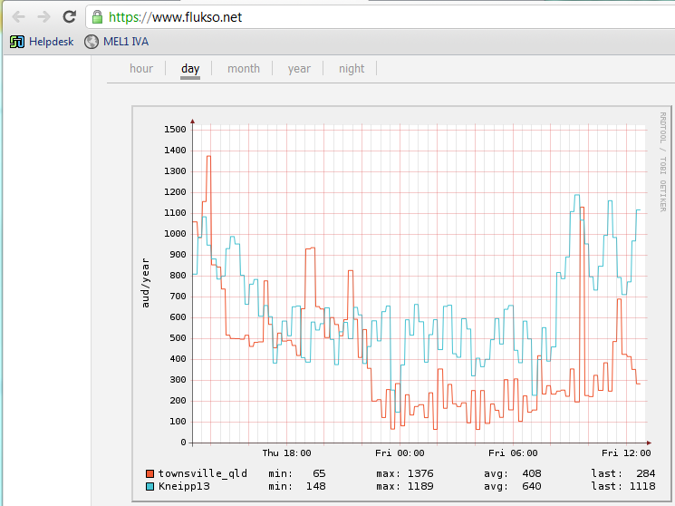

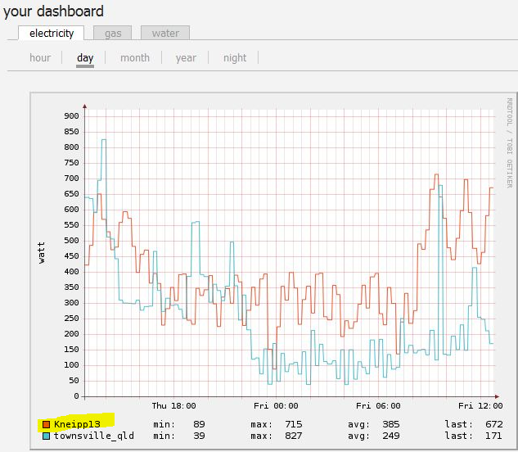
Screen capture from Kneippl3 login both taken at almost the same time, within seconds.

